**Exploratory data analysis**

**ASSIGMENT 1**

By-

Team -4

1.Customer Rating Distribution

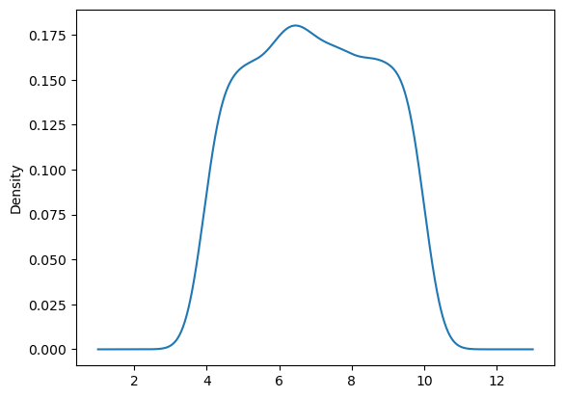

**Observation-**

1.The above normal distribution plot provides valuable insights into customer satisfaction levels. The majority of customers express contentment with the products, as evidenced by the ratings concentrated in the 6-7 range. This suggests a generally positive reception of the offerings.It is crucial to focus attention on products receiving higher ratings (7-9), as they signify exceptional customer satisfaction.

2.Identifying and leveraging these well-received products can contribute significantly to customer loyalty and overall business success.

3.Conversely, products with lower ratings (5-6) warrant careful consideration.

2.Aggregate Sales Across Branches:

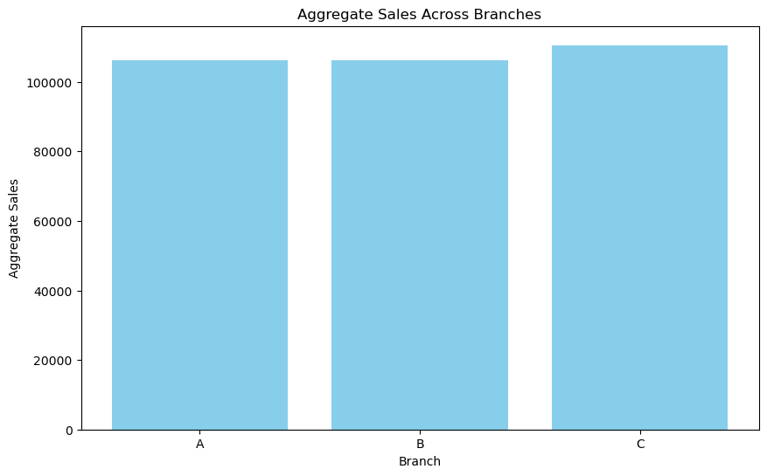

**Observation-**

1. The presented bar graph depicts the total sales across different branches. It is evident from the graph that Branch-C has the highest sales compared to the other two branches, indicating that Branch-C is the leader in terms of sales.

2.Therefore, we can conclude that Branch-C is the most lucrative branch and contributes significantly to the overall business.

3.Most Popular Payment Method

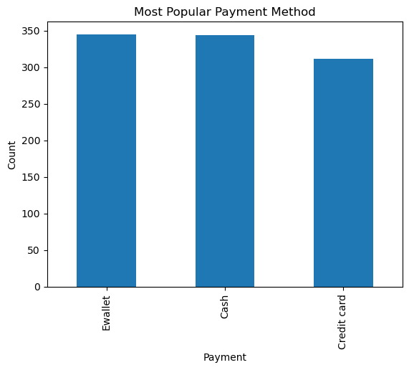

**Observation-**

1. The presented bar graph illustrates the frequency of different payment methods used by customers.The count for credit card usage appears lower than the counts for the other two methods.
2. Overall, it is apparent that E-wallet and Cash show an upward trend in usage, suggesting they are more prevalent among customers compared to credit cards

**Bi variate Analysis**

1. Relationship Between Gross Income and Ratings

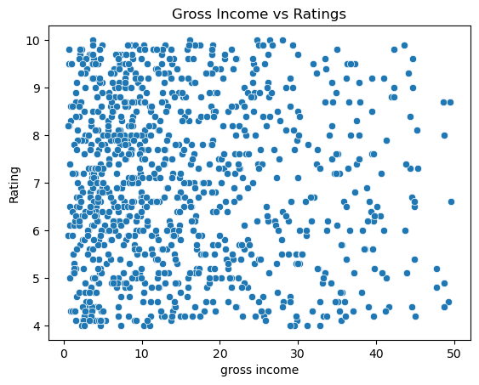

**Observation-**

1.The depicted scatter plot illustrates the relationship between gross income and ratings. A discernible trend emerges, suggesting a negative correlation between gross income and ratings. Specifically, as gross income increases, there is a slight decline in product ratings.

2.This implies that higher levels of income may be associated with somewhat lower customer ratings for the product.

5.Profitability Across Branches

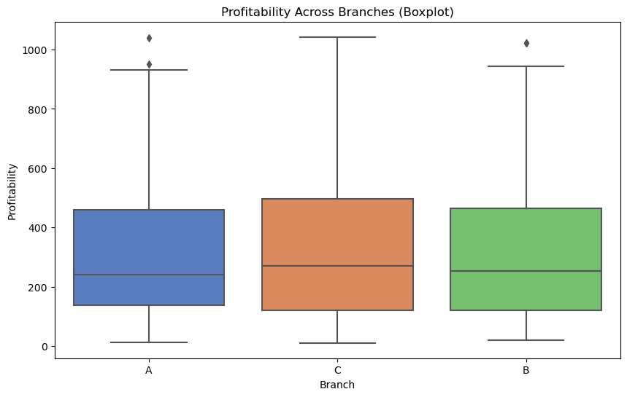

**Observation-**

1.The presented boxplot depicts the total sales across different branches. It is evident from the graph that Branch-C has the highest profit compared to the other two branches, indicating that Branch-C is the leader in terms of profitability.

2.Therefore, we can conclude that Branch-C is the most lucrative branch and contributes significantly to the overall profit of the business

1. Relationship Between Gender and Gross Income

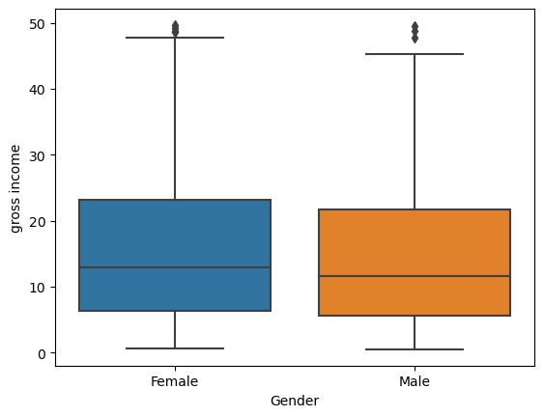

**Observation-**

1.The above boxplot depicts the relation between gender and the gross income.As we can see females earn more gross income than males.

7.Time Trend in Gross Income

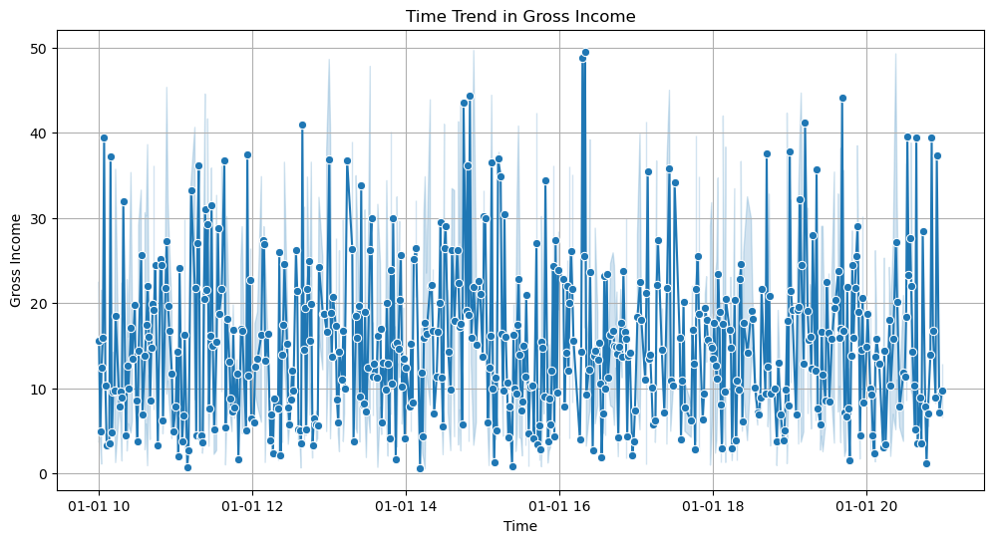

**Observation-**

1. The above line graph shows that the highest number of sales occurred on January 1st, particularly at 4:00 PM. Subsequently, the following two hours also experienced considerable sales activity, although with slightly fewer transactions compared to the peaks sales hour at 4:00 PM.

8.Most Profitable Product Line

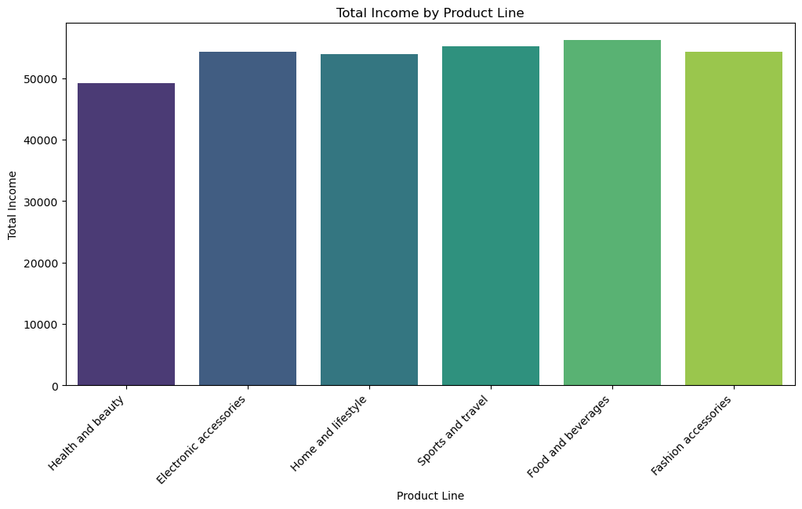

**Observation-**

1.The presented bar plot illustrates the profitability of different products. Notably, it is evident that the 'Food and Beverages' category stands out with the highest profit compared to other products.

2.Conversely, the 'Health and Beauty' category exhibits slightly lower profitability than the other products.

9.Spending Pattern by Gender

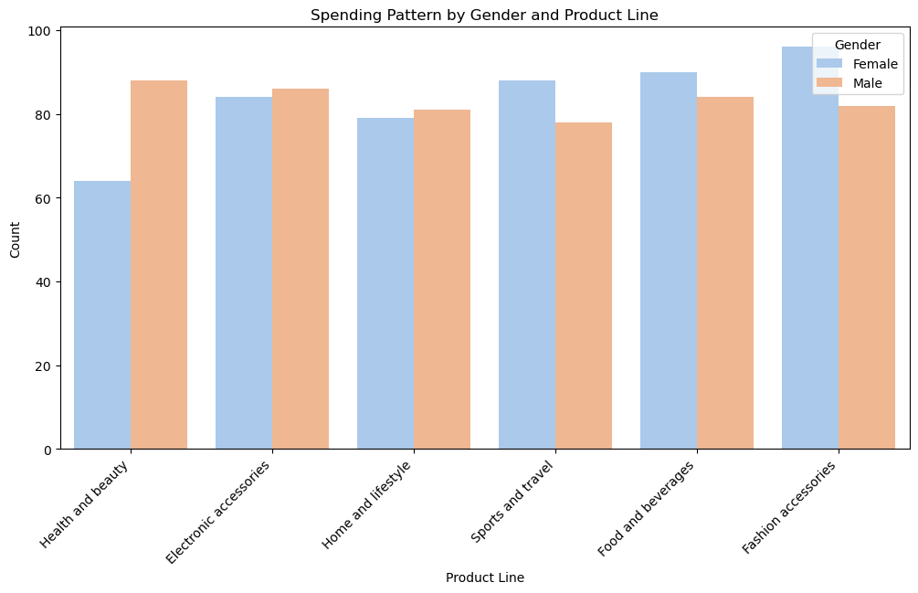

**Observation-**

1.As we can see that for Health and beauty,Electronic accessories,Home and lifestyle males exhibit a more spending pattern compared to females,for sports and travel,Food and beverages,Fashion accessories females exhibit a more spending pattern compared to males

1. Number of Products Bought

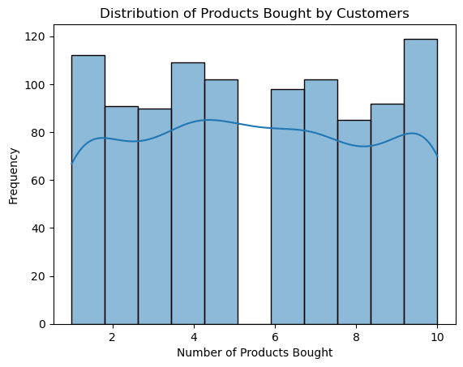

**Observation-**

1.Examining the histogram indicates a substantial portion of customers who made purchases exceeding 10 products, with over 120 individuals falling into this category. Furthermore, a noteworthy observation is the significant number of customers who opted for a minimal purchase, buying only one or fewer than two products.

2. This pattern suggests that by presenting a diverse range of products, customers who initially intended to buy a single item are inclined to explore and ultimately make multiple purchases. This underscores the importance of product variety in enticing customers to broaden their shopping scope and make more extensive transactions.

1. Day of the Week with Maximum Sales

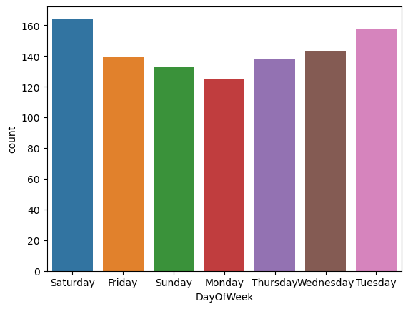

**Observation-**

1.Analyzing the bar plot reveals a pronounced sales trend, with Saturdays standing out as the peak day, drawing in over 160 customers. This surge in customer activity on Saturdays can be attributed to the weekend, where individuals typically engage more in shopping activities.

2.In contrast, Mondays exhibit the lowest sales activity, likely influenced by the start of the workweek, resulting in fewer transactions. Recognizing and understanding these weekly fluctuations is essential for devising targeted marketing strategies and operational adjustments to capitalize on peak sales days and stimulate customer engagement during slower periods.

1. Busiest of Hour Day

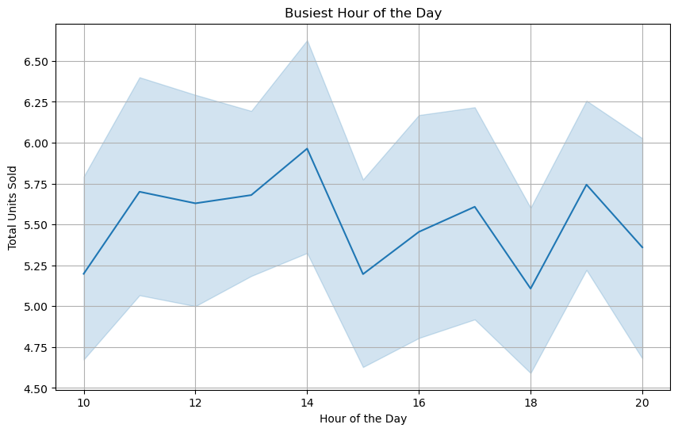

**Observation-**

1.Analyzing the presented line plot unveils that the busiest hour of the day occurs at two o'clock, with a remarkable sales volume surpassing 5.75 units, nearly reaching 6 units within that hour. Conversely, during the day of the week, the lowest number of units are sold at 6 o'clock in the evening, representing a notable dip in supermarket transactions during that specific time.

2.These insights shed light on critical periods of heightened sales activity as well as comparatively slower periods, aiding in strategic decision-making for resource allocation and customer engagement strategies.

1. Focus Product Line

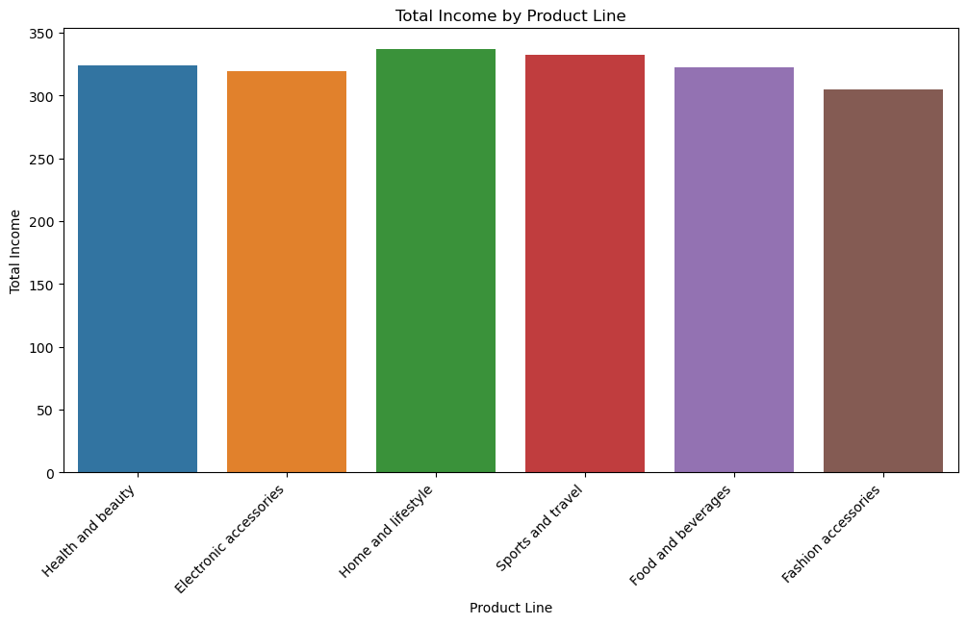

**Observation-**

1.The bar plot provides a comprehensive view of the business's income distribution, revealing a diversified revenue stream catering to both essential and lifestyle-oriented needs. Notably, home and lifestyle, sport and travel, and food and beverages dominate the income landscape, indicating a robust market demand for products integral to consumers' daily lives.

2.However, the comparatively lower contribution from fashion accessories signals a potential area for strategic adjustments. It suggests the importance of staying attuned to rapidly changing trends in the fashion sector or exploring innovative approaches to enhance the appeal of these products.

1. City for Expansion and Focus Products

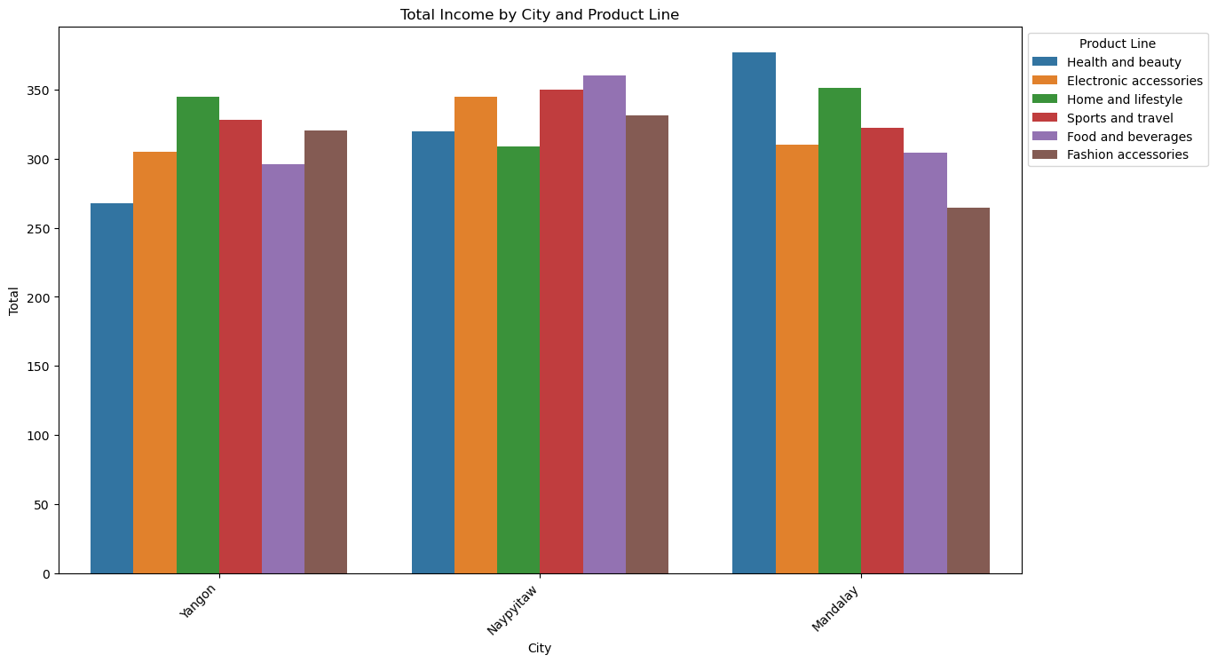

**Observation-**

1.The bar plot clearly illustrates that Naypyitaw city stands out as the primary contributor to both income and sales across various product lines, consistently outperforming the other two cities. Mandalay, on the other hand, takes the lead in Health and Beauty sales, while Yangon demonstrates a higher demand for Home and Lifestyle products. In light of these observations, a strategic expansion plan is recommended.

2.Expanding the business in Naypyitaw and Yangon is advised, given their substantial contributions to overall income. In Naypyitaw, there is a significant demand for Health and Beauty products and Fashion accessories, making these strategic investment areas. Mandalay, with its strong performance in Health and Beauty, could benefit from addressing the lower demand for Electronic Accessories. For Yangon, a focus on Home and Lifestyle products and Fashion accessories aligns with the city's sales trends.

3.Moreover, Fashion accessories emerge as a promising investment for both Naypyitaw and Yangon, complementing their respective market demands. Notably, Naypyitaw exhibits high demand for Food and Beverages, as well as Sports and Travel products, indicating additional opportunities for targeted marketing and product offerings. By adopting a balanced and diversified strategy tailored to the unique market demands of each city, overall business success is likely to be maximized